**Data Preparation/Feature Engineering**

**1. Overview**

The main aim of this project is to:

1. analyze the world happiness and to show which country has the least happiness and which one has the highest percentage of happiness.

The project contains many parts.

1. Dataset
2. Dataset preparation
3. Exploratory data analysis (EDA)
4. Prepare dataset for machine learning model (Feature engineering)
5. Classification
6. Machine learning models (Random Forest, Decision Tree, K Nearest Neighbor, SVM)
7. Comparison

**2. Data Collection**

I have used the dataset which is available in internet and it is prepared by UN from different countries or all countries over the world. By using World Happiness data, I have worked on it and used different algorithms and models to predict the future values.

**3. Data Cleaning**

I have cleaned all the data which were null and also cleaned the missing values from the dataset, in this project I have removed the extra characters from the feature names.

**4. Exploratory Data Analysis (EDA)**

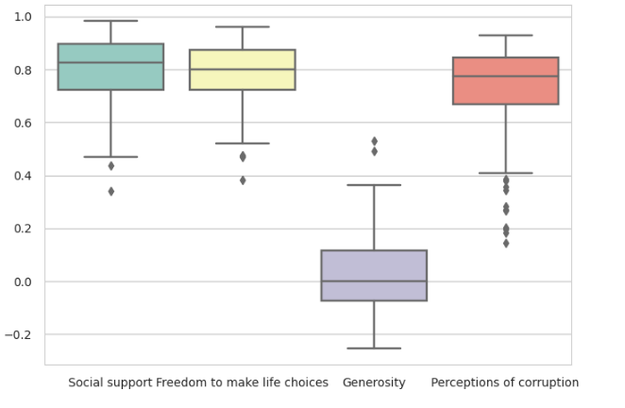

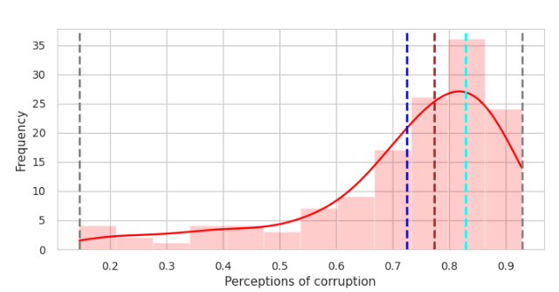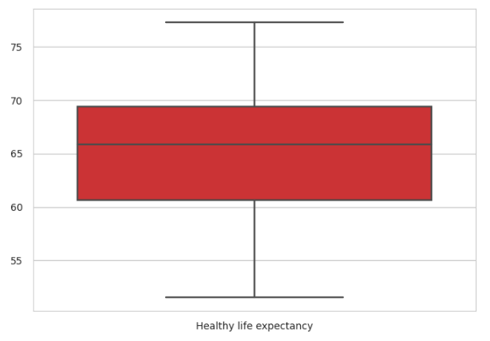

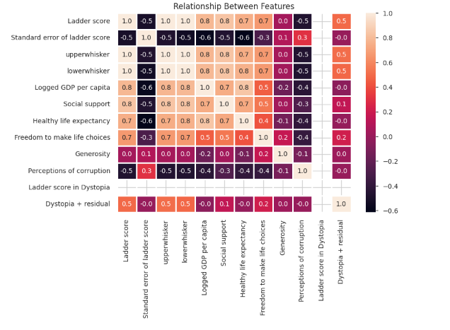

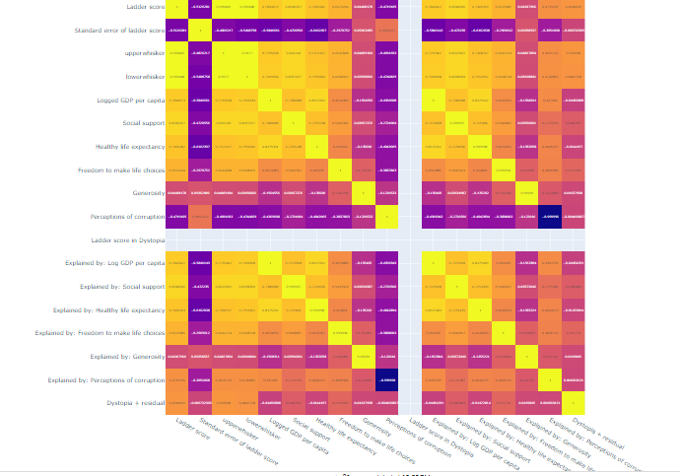

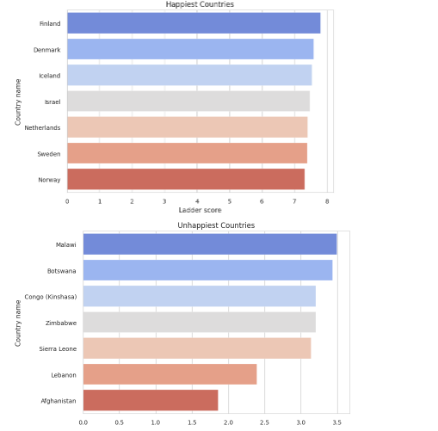

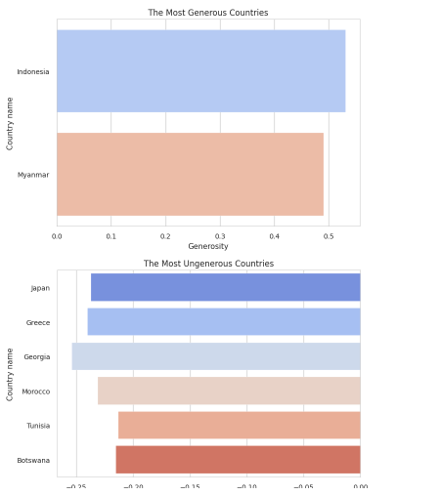

**5. Feature Engineering**

I have changed some columns names which was so complicated and I couldn’t use it easily while training my model so I give them new names and deleted the old names.

**Model Exploration**

**1. Model Selection**

